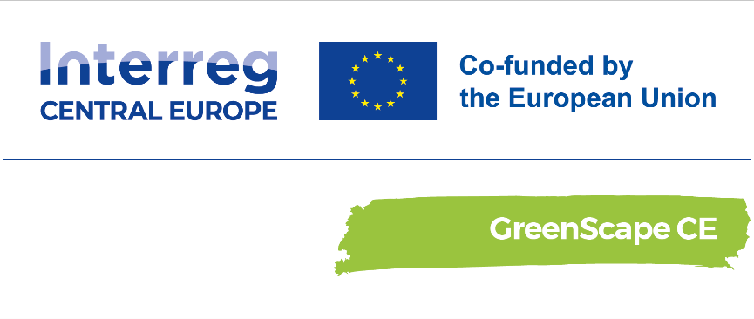

Memorandum of Understanding

​About the project
Cities are growing in central Europe, often turning green areas into grey concrete places. This urban sprawl accelerates climate change's negative effects, such as urban heat islands.
GreenScape CE project paves the way for integrating nature-based solutions (NBS) and green infrastructure (GI) in the grey infrastructure in 5 Central European urban areas, significantly affected by aggravating urban heat island effect: Milano Metropolitan Area, Ptuj, Szeged, Warsaw and Zagreb through peer-to-peer learning, transnational capacity building and participatory decision-making.
The project is committed to enabling the wider uptake of NBS in pilot urban areas by enhancing policy learning and improving multilevel governance structures that will enable better collaboration between decision-makers and local communities.

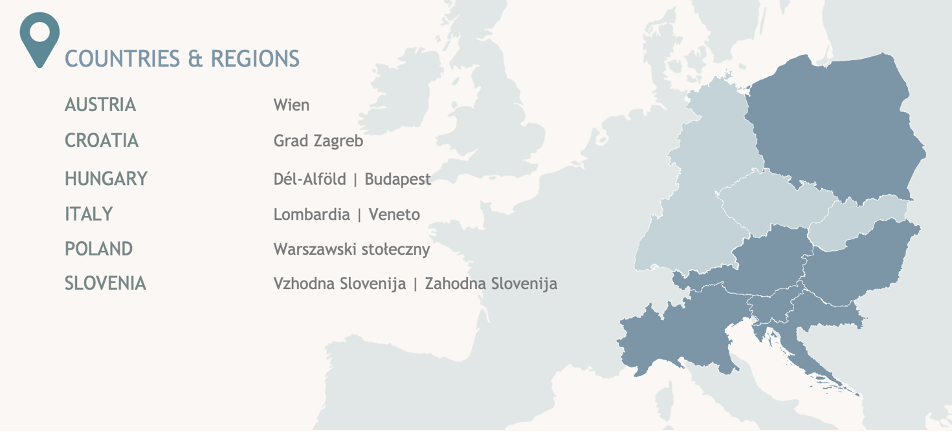

Duration:

Start date: 03.2023

End date: 02.2026

By signing the document you will be able to access multiple benefits such as:

- Networking at local and international level. With as many as 12 partner organisations from six CE countries (AT, HR, HU, IT, PL, SI), stakeholders will get to know and collaborate with foreign administrations, research institutes, NGOs and more;
- Participating in co-creation processes and providing policy recommendations;
- Gain Visibility (on social media, during events, and conferences);
- Exchange practices with the different stakeholders and project partners;
Different degrees of participation are envisaged within the project and stakeholders can choose their level of engagement according to their ambitions and possibilities.
(Please, tick the box for the activities you are interested in – You can tick as many boxes as you are interested)
BE INFORMED
- Subscribe to the project newsletter - informative emails containing information of the developments of the project, events, latest updates and news concerning the topics most dear to the Community of Interest
- Subscribe to the project’s social media channels and contribute to disseminating news about it.
BE CONSULTED
- ​Contribute on the specific Hungarian contents of the project, such as NBS workshops for municiplaities, guidelines, strategies
BE INVOLVED
- ​Attend local events organised to deepen your knowledge of the other stakeholders and make your concerns and recommendations heard.
- ​Participate in co-design processes & various participatory meetings
COLLABORATE
- ​Disseminate and raise the visibility of the project activities and results whenever relevant to the territory/organisation.
- ​Promote events not only to disseminate the project results but also to become testimonials/promoters and, as such, support and build confidence in the project's approach and tools.
EMPOWER
- ​Participate in the co-creation activities to provide insights/needs/expectations concerning the pilot action in Szeged.
- ​Participate in training events aimed to empower local citizens and stakeholders and improve their knowledge.
Considering all the information above, I (name and surname) confirm on behalf of my organisation/municipality (please insert the name of your organisation/municipality) our interest in the above-mentioned project and in taking part in the GreenScape CE project’s community.
All communication with our organisation can be made at the following email address:
Contact person:
e-mail address:

By signing this document, I also accept that:

- My contact will be shared within the consortium of the GreenScape CE Project

YES / NO, THANKS

- Any member of the GreenScape CE’s Consortium will have the possibility to contact me directly
YES / NO, THANKS
If accepted above, Energiaklub and the GreenScape CE’s Consortium will treat your data in compliance with the General Data Protection Regulation (GDPR) and the data management information sheet of Energiaklub. Collected personal data will be treated with confidentiality and will not be transferred to any third party.

Date Signature

The document is non-binding, you may unsubscribe and change your communication permission at any time by getting in touch with Zsófia Pej (telepules@energiaklub.hu or energiaklub@energiaklub.hu).

